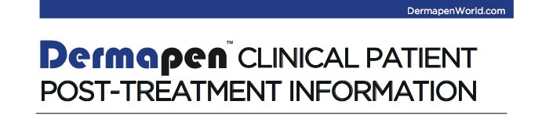

During the skin healing process, minor itching, hives, flaking, or redness may appear. If symptoms persist, please call your DermapenTM practitioner.
Do not pick, squeeze or agitate during the recovery period.

Please avoid the following activities for up to 2 days following a DermapenTM clinical procedure:
- Direct ultra violet exposure (sun and solariums)
- Intensive cardio, exercise or gymnasium regimens
- Excessively hot showers, bathing, spas or sauna
- Spray or self-tanning
- Swimming in chlorinated pools or the ocean
- Tattooing (including cosmetic tattooing)
- Further clinical treatments (including, but not limited to): micro dermabrasion, laser, intense pulsed light, chemical peels, muscle relaxant injections and dermal fillers) should be avoided for up to two weeks.

Please avoid the use of skin care products containing any of the following active resurfacing ingredients for up to 5 days following a DermapenTM clinical procedure:

- Alpha hydroxy acids (AHAs) (including but not limited to) glycolic, lactic or malic acid
- Beta hydroxy acid (BHA) including salicylic acid
- Benzoyl peroxide
- Retinoids (including but not limited to) tretinoin, retinol and retinaldehyde
- Hydroquinone
- High levels of Kojic or azelaic acid
- Alcohol (including but not limited to) isopropyl alcohol/de-natured alcohol/rubbing alcohol

Light, non-occlusive and non-comedogenic make-up may be applied 24hrs post-procedure. DermapenTM recommends Cover RecoverTM as a daily skin protectant and camouflage in one.
If in doubt with any of the above activities or products, please call your DermapenTM practitioner for clarification to when normal activity or use may be resumed.

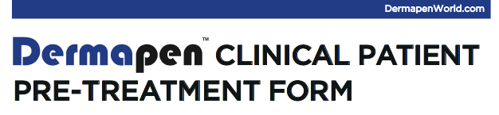

Based on your areas of concern, your DermapenTM practitioner may recommend a series of treatment for optimal results. Your DermapenTM clinical treatment only uses genuine DermapenTM devices and is performed by a DermapenTM qualified practitioner.

CONTRAINDICATIONS:
DermapenTM treatments are not suitable for patients experiencing active
- Papulopustular rosacea
- Acne vulgaris stage III-IV
- Herpes simplex
- Warts
- Scleroderma
- Bacterial/fungal infections

PRECAUTIONS/CONSIDERATIONS:
• Open lesions
• Solar keratosis
• Skin cancer
• Hemophilia
• Pregnancy

Certain health conditions, medications, supplements and lifestyle factors may affect a DermapenTM procedure. All patients are required to complete a DermapenTM Consultation Form prior to any clinical treatment for assessment by a qualified Dermapen practitioner.
If you are prone to herpes simplex (cold sores), it is recommended to take precautions to avoid an outbreak (see pharmacist).
For skins, prone to post-inflammatory hyper-pigmentation, it is recommended to use a melanin inhibiting skin regime for at least 2 weeks prior to a DermapenTM clinical treatment. For Scarring a regime consisting of retinol is recommended for optimal results.
It is essential to have an appropriate home care routine to achieve any optimal result!

COMFORT:
Your DermapenTM practitioner will take all steps to ensure total comfort for your DermapenTM procedure. If at any point you feel discomfort, please inform your practitioner immediately.

HEALTH & SAFETY:
Your DermapenTM treatment only uses sterile, single use consumables throughout the procedure, ensuring complete health and safety.

TREATMENT DURATION:
Pleaseallow45-90minutesforyourDermapenTMclinicaltreatmentincludingpreparation, numbing and post-care.

